ANJALI GOPALAKRISHNAN 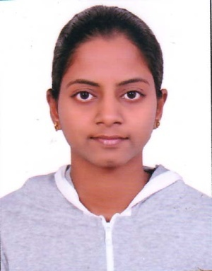

Krishnalayam House Email:anjaligopala@gmail.com
Chingoli po,Haripad Mob:+918592907169
Allapuzha-690532 Res: +919544108505

CAREER OBJECTIVE:
I would like to be a part of an organization where I could use and enhance my knowledge and talent for the development of both the organization and myself.

ACADEMIC PROFILE:

Course | Name of School / College | Board / University | Percentage / CGPA | Year of Passing
Btech  [Computer Science And Engineering] | Mount Zion College Of Engineering ,Pathanamthitta | Mahatma Gandhi University | 7.30(FIRST CLASS) | 2016
12TH | Kerala Education Senior Sec School, New Delhi. | CBSE | 62% | 2012
10TH | Kerala Education Senior Sec School, New Delhi. | CBSE | 7.8/10 | 2010
PROJECT DETAILS:
PROJECT TITLE | IMAGE ENCRYPTION THEN COMPRESSION SYSTEM
 | The images have to be encrypted before compression to give high level security. The image encryption design to operate in the prediction error domain to provide in a sensible way to give high level security. An arithmetic coding based approach can be exploited to efficiently compress the encrypted images. The proposed compression approach applied to encrypted images is only slightly worse, in terms of compression efficiency than the disambiguation lossless image coders which take original unencrypted images as inputs.
PLATFORM | ASP.NET,MYSQL SERVER

OTHER PROJECT DETAILS:
PROJECT TITLE | 1)ADMISSION MANAGER SYSTEM  2)MATRIMONY WEBSITE  3)USED CAR WEBSITE  4)FEE MANAGEMENT SYSTEM  5)HOSPITAL MANAGEMENT
PLATFORM | PHP(CORE,OOPS,MVC,CODEIGNITOR), ASP.NET,MYSQL SERVER
TECHNOLOGIES USED | JQUERY,AJAX,JAVASCRIPT,CSS&HTML5

ADDITIONAL QUALIFICATION
- Successfully completed training in PHP course of 2 month in Bell Technolabs, Ernakulam.
EXPERIANCE
- Worked in Bell technolabs, palarivattom for 6 months

PERSONAL SKILLS
- Quick learner
- Hard working
COMPUTER SKILLS
- Language: C,C++,Java and Php

PERSONAL PROFILE

Name : Anjali Gopalakrishnan
Father’s name : Gopalakrishnan R
Mother’s name : Prasanna Gopalakrishnan
Date of birth : 01-08-1994
Marital status : Single
Nationality : Indian
Languages Known : English, Hindi and Malayalam
Hobbies : Listening to music

DECLARATION

As the enclosed resume simply summarizes my capabilities and career history, there is considerably more to relate. I would appreciate the opportunity to meet with you personally to specifically discuss what I could do for your organization.

PLACE: Kerala (ANJALI GOPALAKRISHNAN)

